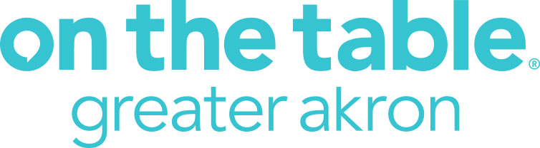

Customizable E-newsletter Articles

*For an organization hosting one or multiple conversations

[Headline] Your voice matters: Join us for On the Table

[Body Copy] On the Table Greater Akron is a one-of-a-kind initiative where thousands of diverse residents from all walks of life gather together to share a meal and discuss meaningful ideas to strengthen our community. Akron Community Foundation is championing this initiative and invites anyone who lives, works, worships or attends school in Summit or Medina counties to mealtime conversation with their family, friends, neighbors or colleagues.

[Insert your organization name here] will be hosting [number of conversations] at [location and time] on Thursday, Oct. 3 and we invite you to join in the conversation with us. Please contact [insert name of employee managing OTT] to attend our On the Table gathering.

If you’d like more information or you can’t attend our gathering but want to find one you can join, visit onthetableakron.com and sign up for emails.

*For an organization that wants to promote On the Table in general

[Headline] Your voice matters. Let it be heard.

[Body Copy] On the Table Greater Akron is a one-of-a-kind initiative where thousands of diverse residents from all walks of life gather together to share a meal and discuss meaningful ideas to strengthen our community. Akron Community Foundation is championing this initiative and invites anyone who lives, works, worships or attends school in Summit or Medina counties to join in a mealtime conversation with their family, friends, neighbors or colleagues on Thursday, Oct. 3.

Visit onthetableakron.com for information about becoming a host. Not interested in hosting your own conversation? Sign up to receive the e-news updates about On the Table, including information about public conversations that will be available closer to the date. Questions? Contact info@onthetableakron.com.

